**ARMY INSTITUTE OF TECHNOLOGY**

**LAB MANUAL**



|  |  |
| --- | --- |
| **Name of Subject** | **Human Computer Interaction Lab** |
| **Department** | **Information Technology** |
| **Subject Code** | **314447** |
| **TW/OR/PR** | **OR** |
| **Marks** | **50** **(Credits:01)** |
| **Course (Pattern)** | **2019** |
| **Year** | **TE** |
| **Semester** | **1** |

**List of Experiments**

(As given by SPPU)

|  |  |  |
| --- | --- | --- |
| **Sr. No** | **Title** | **Page No** |
| 1 | Identify and observe bad designs |  |
| 2 | The Jugad |  |
| 3 | Feedback and Constraint |  |
| 4 | Prototype and wire frame |  |
| 5 | CSS |  |
| 6 | CMS tool |  |
| 7 | Evaluation of Interface |  |

**Pre-requisite for Lab**

|  |  |
| --- | --- |
| **Companion Courses** | |
| Code | Subject |
| 314447 | Human Computer Interaction Lab |
| **Prerequisite Courses/Lab** | |
| Code | Subject |
|  | Computer Graphics |
|  | Problem Solving and Object-Oriented Technologies |

**Learning Objectives**

|  |  |
| --- | --- |
| Sr. No | Objective |
| 1 | To study the field of human-computer-interaction |
| 2 | To gain an understanding of the human part of human-computer-interactions. |
| 3 | To learn to do design and evaluate effective human-computer-interactions. |
| 4 | To study HCI models and theories |
| 5 | To understand HCI design processes. |
| 6 | To apply HCI to real life use cases. |

**Course Outcomes**

On completion of the course, students will be able to–

|  |  |
| --- | --- |
| Sr. No | Course Outcomes |
| 1 | Differentiate between good design and bad design. |
| 2 | Analyze creative design in the surrounding. |
| 3 | Assess design based on feedback and constraint |
| 4 | Design paper-based prototypes and use wire frame. |
| 5 | Implement user-interface design using web technology. |
| 6 | Evaluate user-interface design using HCI evaluation techniques. |

**Precautions / Lab Safety Do's and Don'ts/ Lab Etiquettes**

|  |  |
| --- | --- |
| Sr. No | Details |
| 1 | The use of personal audio or video equipment is prohibited in the laboratory |
| 2 | Keep work area neat and free of any unnecessary objects. |
| 3 | Always perform the experiments as directed by your instructor. |
| 4 | Never work in the laboratory without the supervision of an instructor. |
| 5 | Mobile Phones are strictly prohibited in Laboratory |
| 6 | Keep your bags outside the laboratory. |
| 7 | Make entry in the Laboratory Logbook |

**Evaluation Guidelines (Rubrics)**

(Similar guidelines pertaining to each subject (lab) shall be used to evaluate **each experiment** performed in the lab)

|  |  |  |  |  |
| --- | --- | --- | --- | --- |
| **Grade** | Poor | Average | Good | Outstanding |
| **Marks** | 0-3 | 4-5 | 6-8 | 9-10 |

|  |  |  |  |
| --- | --- | --- | --- |
| **Criteria** | **Grade** | | **Marks** |
| Set-up and Equipment Care | Poor  (0-3) | Set-up of equipment is not accurate, help is required with several major details |  |
| Average  (4-5) | Set-up of equipment is generally workable with several details that need refinement |
| Good  (6-8) | Set-up of equipment is generally accurate with 1 or 2 small details that need refinement |
| Outstanding  (9-10) | All equipments accurately placed |
| Following Procedure | Poor  (0-3) | Lacks appropriate knowledge of the lab procedures. Often requires help from the teacher to even complete basic procedures |  |
| Average  (4-5) | Demonstrates general knowledge of lab procedures. Requires help from the teacher with some steps in procedures. |
| Good  (6-8) | Demonstrates good knowledge of the lab procedures. Will discuss with peers to solve problems in procedures. |
| Outstanding  (9-10) | Demonstrates very good knowledge of the lab procedures. Gladly helps other students to follow procedures. |
| Data Collection | Poor  (0-3) | Measurements are incomplete, inaccurate and imprecise. Observations are incomplete or not included. Symbols, units and significant figures are not included. |  |
| Average  (4-5) | Measurements are somewhat inaccurate and imprecise. Observations are incomplete. There are 3 or more minor errors using symbols, units and significant digits or 2 major errors |
| Good  (6-8) | Measurements are mostly accurate. Observations are generally complete. Work is organized. Only 2 or 3 minor errors using symbols, units and significant digits. |
| Outstanding  (9-10) | Measurements are both accurate and precise. Observations are very thorough and may recognize possible errors in data collection. Work is neat and organized. Includes appropriate symbols, units and significant digits. |
| Analysing and Concluding | Poor  (0-3) | Provides limited analysis of the data. Demonstrates limited ability to draw conclusions based on the data. |  |
| Average  (4-5) | Provides some analysis of the data. Demonstrates some ability to draw conclusions based on the data. |
| Good  (6-8) | Provides sufficientanalysis of the data. Draws valid conclusions based on the data. |
| Outstanding  (9-10) | Provides rich analysis of the data. Draws insightful conclusions based on the data. |
| Safety | Poor  (0-3) | Proper safety precautions are consistently missed. Needs to be reminded often during the lab. |  |
| Average  (4-5) | Proper safety precautions are often missed. Needs to be reminded more than once during the lab. |
| Good  (6-8) | Proper safety precautions are generally used. Uses general reminders of safe practices independently. |
| Outstanding  (9-10) | Proper safety precautions are consistently used. Consistently thinks ahead to ensure safety. Will often help other students to conduct labs safely. |
| Specifications  (Computer Program) | Poor  (0-3) | The program is producing incorrect results. |  |
| Average  (4-5) | The program produces correct results but does not display them correctly. |
| Good  (6-8) | The program works and produces the correct results and displays them correctly. It also meets most of the other specifications. |
| Outstanding  (9-10) | The program works and meets all of the specifications. |
| Readability  (Computer Program) | Poor  (0-3) | The code is poorly organized and very difficult to understand. |  |
| Average  (4-5) | The code is readable only by someone who knows what it is supposed to be doing |
| Good  (6-8) | The code is fairly easy to understand. |
| Outstanding  (9-10) | The code is exceptionally well organized and very easy to follow. |
| Reusability  (Computer Program) | Poor  (0-3) | The code is not organized for reusability. |  |
| Average  (4-5) | Some parts of the code could be reused in other programs. |
| Good  (6-8) | Most of the code could be reused in other programs. |
| Outstanding  (9-10) | The code could be reused as a whole, or each routine could be reused. |
| Documentation  (Computer Program) | Poor  (0-3) | The documentation is simply comments embedded in the code and does not help the reader understand the code. |  |
| Average  (4-5) | The documentation is simply comments embedded in the code with some simple header comments separating routines |
| Good  (6-8) | The documentation consists of embedded comment and some simple header documentation that is somewhat useful in understanding the code. |
| Outstanding  (9-10) | The documentation is well written and clearly explains what the code is accomplishing and how. |
| Timely submission  (Computer Program) | Poor  (0-3) | The code was more than 2 weeks overdue. |  |
| Average  (4-5) | The code was within 2 weeks of the due date. |
| Good  (6-8) | The program was delivered within a week of the due date. |
| Outstanding  (9-10) | The program was delivered on time |
| Efficiency  (Computer Program) | Poor  (0-3) | The code is huge and appears to be patched together. |  |
| Average  (4-5) | The code is brute force and unnecessarily long |
| Good  (6-8) | The code is fairly efficient without sacrificing readability and understanding. |
| Outstanding  (9-10) | The code is extremely efficient without sacrificing readability and understanding |

# Assignment No:1

## Aim: Identify and observe bad designs Problem statement:

Students are expected to submit minimum of 3 to 5 photographs of bad designs in their surrounding or home or any product or neighborhood and create a report mentioning why is it bad? They can submit word/pdf file having photos and description, source of photos and place and mention why is it bad and discuss the outcome during lab session

## Theory:

**There are 2 main types of designs**

## Good design

A design of any product or an interface is generally considered to be good when it is Simple, Usable, Learnable, Intuitive, and has a Waw factor.

## Bad design

A design difficult to use, understand its functionality and not interactive enough to understand its current state is called as Bad design.

Few real life examples of products and interfaces are mentioned along with its relevant explanation.

|  |  |
| --- | --- |
|  | The handle of the drawer is vertical in this shelf whereas usually drawer handles are horizontal so when I first tried to open the drawer I thought I have turn the knob to the left or right direction and then pull it to open it. But this was not the case, the handle was fixed and the drawer had to opened just by pulling it. |

|  |  |
| --- | --- |
|  | Fuel Indicator on a bike blink when the fuel is very low. It does not have a perfect fuel level which is not useful because you can't guess number of kilometers it can from a destination. |
|  | Hard to find particular app as they are not arranged in any order. Every time I want to open app which I don’t use frequently I end up wasting time. |
|  | The picture shows a shelf used to keep things needed daily.  For someone new, it’s confusing to know from where to open this shelf.  The shelf actually opens by pulling at the bottom of the shelf. |

|  |  |
| --- | --- |
|  | This drawer is from our kitchen.  We can open only one drawer at a time and it gets opened partially. We can’t open both simultaneously. |
|  | This drain is higher than the ground surrounding it. |
|  | Cello tape rolls don’t have a clear marking for the free end of the tape.  We always need to scratch through the surface of it to find out the rough spot and then pull it out.  This can cause the tape to tear from between causing damage |

|  |  |
| --- | --- |
|  | The rightmost switch controls the second socket, and the left switch controls first socket.  It’s really confusing to find which switch controls which socket. |
| WhatsApp Image 2020-07-10 at 6.24.02 PM | Here the fault in the design, it has an extra button or there is one socket missing.  One more fault is; it is placed near the wardrobe so whenever the door is opened anything that is plugged there collides with the door. |
|  | So, I received this cup as a Birthday gift.  The problem with this cup is it’s really difficult to drink anything from it because of its odd designing. |

|  |  |
| --- | --- |
|  | The top of cup is narrow than the rest of it which makes it difficult to drink anything from it. |
|  | This storage unit installed under a bed cannot be opened completely due to lack of space. It is difficult to access items placed towards the inner end of the unit. |

# Assignment No:2

## Aim: The Jugad

**Problem statement:**

Humans are very creative and often use it to get work done with available set up and resources. Students are expected to identify Jugad (things used creatively but not meant for that) things and submit minimum of 3 to 5 photographs of jugad in their surrounding or home or neighborhood. Prepare a report mentioning the Jugad and source of photos. Discuss the outcome during lab session.

## Theory:

We come across many such jugad in and around our neighborhood or surrounding. The key concept here is use items or artifacts meant for other useful things to be used as temporary solution to carry out certain activity for which it is not meant for.

|  |  |
| --- | --- |
|  |  |
| **Car Window Sunshade** |  |

|  |  |
| --- | --- |
| How to rescue a smartphone from water damage | We can put wet phone in a bowl of rice for some hours, the rice pulls out the moisture from the phone and this helps the phone to dry out quickly. |
|  | This is the money plant which is in our gallery and here the supporting rod which supports the plant is a plastic stick seen in mops. |

|  |  |
| --- | --- |
|  | Using stool as a stump in gully cricket |
|  | Table-fan is used as wall-fan |
|  | Old rakhi used as a curtain tie-back |

|  |  |
| --- | --- |
|  | plants are grown in PVC pipe |
|  | Plants are grown in tyre. |
|  | Fields often has attacked by rats, snakes, buffaloes, wild boars as well as eagles, peacocks and various birds. They damage the yield and can cause huge loss to farmers. So a low cost jugad of discarded glass bottles and nails are used. |

|  |  |
| --- | --- |
| IMG20200720113620 | Plastic Bucket |
|  | Using this old toothbrush as a sprinkler paintbrush |
|  | This jugaad is very often use jugaad in Indian house as we can see container is loose and can open easily and we cannot use it for any liquid material.  If we put some plastic bag in between container and cap it will not open easily and it will provide some air tightness to container. |

# Assignment No:3

## Title :- Feedback and Constraints

**Aim: To find the products with Feedback and Constraints**

## Problem statement:

Products or interfaces should offer useful feedback to understand the state and have constraints to avoid mistakes while using them. Students are expected to identify and analyze minimum of 5 interfaces or products offering feedback and constraint. Prepare a report clearly showcasing feedback and constraint and support it with minimum of 5 photographs taken in their surrounding or home or neighborhood. Discuss the outcome during lab session.

## Theory:

**What is Feedback?**

Feedback means the product interface shows some form of response or reaction. The interface should talk back to the user to inform them about what’s happening. In other words the user must understand whether the operations are being carried out properly or not. Many times these feedback messages provide proper guidance to the user about what should be the next step to be done in order to complete the task in correct manner.

For example: The button should display a ‘pressed’ state, Playing a spinning wheel while opening any application, or show a progress bar to keep the user in the loop.

## What are Constraints?

A constraint is a limit or restriction. Every application or product have some kind of limitation or rules, depending on which the product works. Sometimes product has good constraints which stops the users from making mistakes. These are useful constraints. They always help user for smooth operation of a device or a system. Entering wrong data, pressing wrong button, selecting incorrect option this type of mistakes can be nullified by the good constraints. Sometimes there is a need of constraints to avoid such problems but they are not present.

## What is the need of Feedback and Constraints?

By receiving feedback from the system the user will not become panic and system gets enough time for processing. Feedback is essential to guide and inform your decision making and influence innovations. It helps in maintaining transparency between the product and the user.

## Examples with Explanation

|  |  |
| --- | --- |
| **Example** | **Explanation** |
|  | Fan regulator gives us a feedback regarding increasing and decreasing speed. The direction of the arrow shows the increasing speed.  It also have the constraint that you cannot increase the speed more than 4th level. The circles are indicating those levels. |
|  | There is a Notification sound when mobile is connected to a laptop. And message is displayed about what you would like to do next.  There is Constraint like unless you select the file transfer option, you will not able to do any file transfer operation between laptop and mobile. |
|  | In the AC remote good constraint is that you can’t raise the temperature above 31°c and below 16°c. You can see the current temperature on the display panel, which is feedback. |

|  |  |
| --- | --- |
|  | you want to paste some content the UI gives you feedback regarding different options available.  Sometimes options like paste are disabled when we can’t use them. This is a constraint. |
|  | The online products have feedback in the form of ‘Star rating’ and the average of the rating is done with number of users rated which is written on the right.  There is a quantity constraint with an online product during a big sale. |

## Examples where feedback is needed but not present.

|  |  |
| --- | --- |
|  | There should be a mechanism to sense a bed time of the members and regulator should be turned off. |
|  | There should be a mechanism to sense how much gas is used from a cylinder. |
|  | An indication beep is required to know that laptop is fully charged. |

|  |  |
| --- | --- |
|  | The iron should be automatically turned off if not used for at least 2 mins |
|  | There is no limit in dialing numbers on the dial pad. It should there so that one cannot dial numbers more than 10. |

## Conclusion:

Identified and analyzed interfaces and products which gives feedback and have some constraints.

**Aim: Prototype and Wireframe**

# Assignment No:4

## Problem statement:

Students are expected to choose a problem statement and identify –

Types of users going to use (age, experience, environmental conditions during use etc.) Minimum 3 scenarios of use Create paper-based prototypes for scenarios.

Use any open-source tool to wire frame scenarios.

## Theory:

**There are 3 main types of users**

## Novices

For the novice user of a system, progress is slow because of the limitations of working memory. Chunking is almost entirely absent.

Systems used by novices require more feedback and more opportunities for closure.

## Knowledgeable Intermittent users

These users need consistent structures, good help facilities, good documentation.

## Expert Frequent users

These users have fast response time and will require brief feedback.

Experts organize their knowledge according to a higher conceptual structure. They can recall more than novices because their knowledge is chunked.

Expert users will look for keyboard shortcuts, abbreviated sequences.

Experts can find constant confirmation screens irritating - Use these only when important.

## What is Prototype?

A prototype can be any mock-up or demo of what a website or any application will look like, when it goes live. It is generally drawn by hand on a paper. While it may not have all the bells and whistles of a final website build, it can give you a really good idea of the functionality, user journey and flow through a website. A website prototype is essentially a high-fidelity visual version of the site that allows you to link between screens and demonstrate how the website would work before going to build.

Creating website prototypes is useful in many ways. Most importantly, a prototype allows a user to interact with the website almost as it would behave when built. While it may not include any animation or transition styles it does operate on a basic level to let the user navigate and interact with certain elements on the site.

Prototyping is hugely beneficial in the design process as it allows us to save a lot of time early on in a web project. Identifying areas for improvement during the design stage is a lot easier to rectify than

finding out these problems once the site has gone into development. Prototyping is also beneficial to show users who may not understand flat visuals as easily as an interactive version of the site.

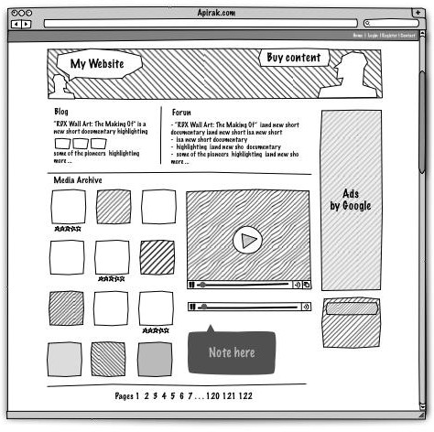**Example of a Prototype:**

## High-Fidelity and Low-Fidelity Designs

Low-fidelity prototypes are often paper-based and do not allow user interactions. They range from a series of hand-drawn mock-ups to printouts. In theory, low-fidelity sketches are quicker to create. Low- fidelity prototypes are helpful in enabling early visualization of alternative design solutions, which helps provoke innovation and improvement. An additional advantage to this approach is that when using rough sketches, users may feel more comfortable suggesting changes.

High-fidelity prototypes are computer-based, and usually allow realistic (mouse-keyboard) user interactions. High-fidelity prototypes take you as close as possible to a true representation of the user interface. High-fidelity prototypes are assumed to be much more effective in collecting true human performance data (e.g., time to complete a task), and in demonstrating actual products to clients, management, and others.

## What is the need of wireframes?

Wireframing is a way to design a website service at the structural level. A wireframe is commonly used to layout content and functionality on a page which takes into account user needs and user journeys.

Wireframes are used early in the development process to establish the basic structure of a page before visual design and content is added. The aim of a wireframe is to provide a visual understanding of a page early in a project to get stakeholder and project team approval before the creative phase gets under way.

It is quicker and cheaper to review and amend the structure of the key pages in a wireframe format. Iterating the development of the wireframes to a final version will provide the client and the design team confidence that the page is catering to user needs whilst fulfilling the key business and project objectives. From a practical perspective, the wireframes ensure the page content and functionality are positioned correctly based on user and business needs. And as the project moves forward, they can be used as a good dialogue between members of the project team to agree on the project vision and scope.

### Example of a Wireframe:

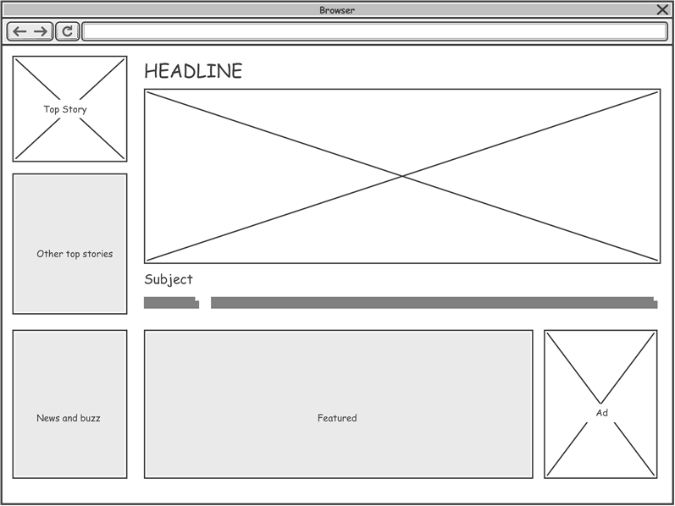

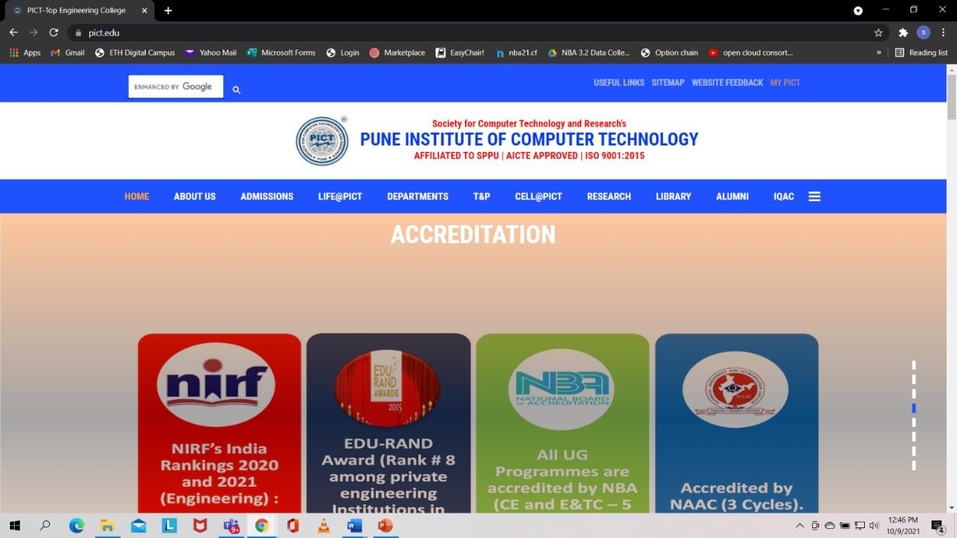

|  |  |
| --- | --- |
|  |  |
|  |  |
|  |  |
|  |  |

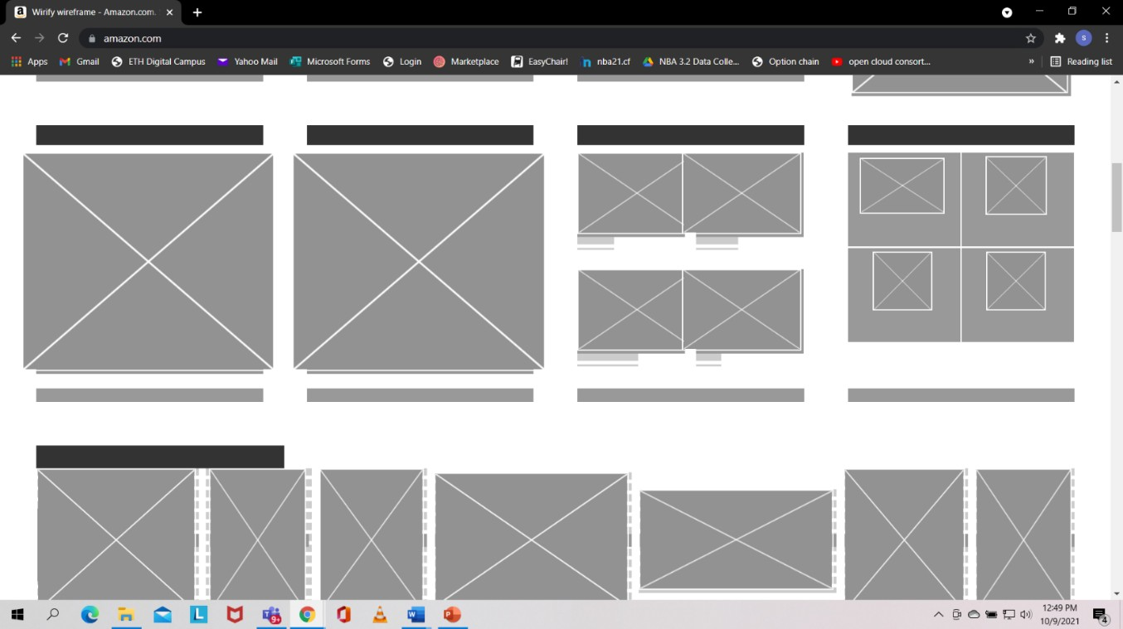

### Conclusion:

Prototypes are drawn and Wireframes are created using software tools

**Aim: CSS**

# Assignment No:5

## Problem statement:

Students are expected to design minimum of 5 web pages using CSS for the problem statement chosen in assignment no. 4. Apply CSS properties Border, margins, Padding, Navigation, dropdown list to page.

## Theory:

**CSS**

* Cascading Style Sheets (CSS) form the presentation layer of the user interface.
  + Structure (XHTML)
  + Behavior (Client-Side Scripting)
  + **Presentation (CSS)**

## Types of CSS

1. External style sheet
2. Embedded styles
3. Inline styles

### Inline Style

* Inline styles
* Add styles to each tag within the HTML file
* Use it when you need to format just a single section in a web page

### Example

**<h1 style=“color:red; font-family: sans-sarif”>IU</h1>**

### Internal Stylesheet Embedded

* A style is applied to the entire HTML file
* Use it when you need to modify all instances of particular element (e.g., h1) in a web page

**Example <style>**

**h1 {color:red; font-family:sans-serif}**

### </style>

* **External Stylesheet**
* External style sheets
* An external style sheet is a text file containing the style definition (declaration)
* Use it when you need to control the style for an entire web site
* Example
* h1, h2, h3, h4, h5, h6 {color:red; font-family:sans-serif}
* Save this in a new document using a .css extension

### CSS Syntax

A CSS rule set consists of a selector and a declaration block:

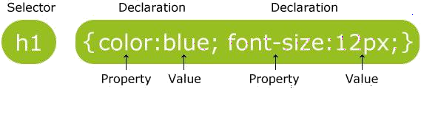

The **selector** points to the HTML element you want to style. The **declaration** block contains one or more declarations separated by semicolons. Each declaration includes a property name and a value, separated by a colon.

### The CSS Box Model

All HTML elements can be considered as boxes. In CSS, the term "box model" is used when talking about design and layout.

The CSS box model is essentially a box that wraps around HTML elements, and it consists of: margins, borders, padding, and the actual content.

It allows us to place a border around elements and space elements in relation to other elements.

## The image below illustrates the box model.

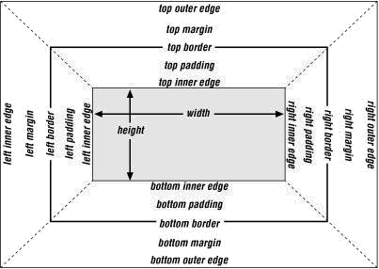

**Property Description**

|  |  |
| --- | --- |
| **border** | **all the individual border properties in one property.** |
| **This is called a shorthand property.** |
| **Border-** | **none| dotted | dashed | solid | double | groove | ridge | inset | outset** |
| **style** |
| **border-** | **is used to set the width of the border. The width is set in pixels,** |
| **width** | **or by using one of the three pre-defined values:** |
|  | **thin, medium, or thick.** |
| **border-** | **is used to set the color of the border** |
| **color** |

### Margin

The margin clears an area around an element (outside the border). The margin does not have a background color, and is completely transparent. The top, right, bottom, and left margin can be changed independently using separate properties. A shorthand margin property can also be used, to change all margins at once. It is also possible to use negative values, to overlap content

|  |  |
| --- | --- |
| **Value** | **Description** |
| auto | The browser calculates a margin |
| *length* | Specifies a margin in px, pt, cm, etc. Default value is  0px |

% Specifies a margin in percent of the width of the containing element

|  |  |
| --- | --- |
| inherit | Specifies that the margin should be inherited from the |
|  | parent element |

 **Padding**

The padding clears an area around the content (inside the border) of an element. The padding is affected by the background color of the element. The top, right, bottom, and left padding can be changed independently using separate properties. A shorthand padding property can also be used, to change all paddings at once.

 **Navigation**

There are two ways to create a horizontal navigation bar. Using **inline** or **floating** list items. The display property of css is used for navigation bar. The value block will create a vertical navigation bar and inline will create a horizontal navigation bar.

### Example:

**Display: inline | block**

Drop Down list can be created by using HTML onordered lists tags <ul> and list items <li>. One can set below CSS properties for lists.

|  |  |  |
| --- | --- | --- |
| **Property** | | **Description** |
|  | list-style | Sets all the properties for a list in one declaration |  |
| list-style-image | Specifies an image as the list-item marker |
| Eg. url(“image.gif”); |
| list-style-position | Specifies if the list-item markers should appear inside or outside the |
| content flow |
| Inside | outside | initial |
| list-style-type | Specifies the type of list-item marker |
| Circle | square | decimal | lower-alpha | lower-greek | lower-latin | lower- |
| roman | upper-alpha | upper-latin | upper-roman |

## Conclusion

Various CSS properties have been studied and used for creation of interactive web page.

## Expected sample Output

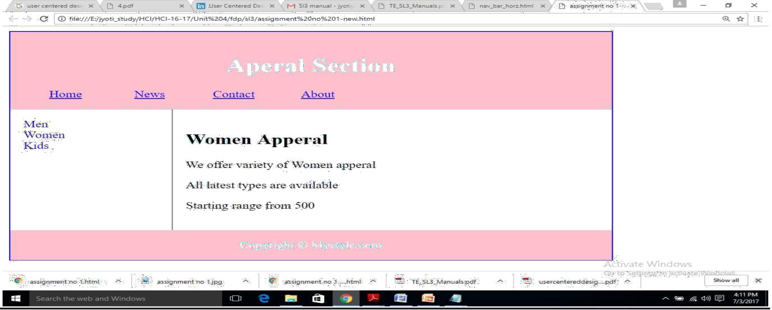

**Lab. Based FAQ**

1. What is CSS?
2. What are the types of writing CSS?
3. What are various CSS Properties?
4. What is CSS Box model?

**Aim: CMS tool**

# Assignment No:6

## Problem statement:

Develop website using any CMS tool which falls into one of the categories blog, social networking, News updates, Wikipedia, E-commerce store. Website must include home page, and at least 5 forms. Use WordPress/ Joomla/ Drupal /PHP/ CSS/Bootstrap/ JavaScript.

## Theory:

**Introduction to CMS**

* Contents of websites may consist of text, graphics, sounds, movies and so on,
* Content Management Systems are used as a tool to publish such contents onto a website easily and efficiently, it also helps to separate web page design from content creation.
* Content Management Systems are usually developed using a combination of programming/scripting languages and database technologies, in which they work well together.
* In order to manage the process of creating and presenting information on web pages, this software consists of the following:
  + **Client software:** is used to present a user interface to help users add, change, or delete information on web pages, for example a web browser such as Internet Explorer or Mozilla Firefox are used to display web based user interfaces.
  + **Database software:** is used as a tool to store data or information for future retrieval or manipulation, for example Microsoft SQL server, Oracle and MySQL databases.
  + **Web programming languages and scripts:** these are used as a tool to communicate to the underlying database to extract, change, save, or remove data from and to the database, for example JSP, PHP, Java Servlets, Perl and so on.
* **Template page:** This is usually created by Hyper Text Mark up Language (HTML) to keep the website layout consistent in order to preserve the corporate image by keeping the same look and feel through out the system.

### Advantages of Content Management Systems

* It helps content authors to update or publish information onto the website without any need for web programming knowledge, which in turn reduces the cost of professional assistance.
* It allows content writers to concentrate on writing information without worrying about the design of the website. They can easily add, edit, and remove contents from and to the database by using simple user interfaces.
* It allows web content maintenance carried out easily and efficiently to meet business needs.
* It provides a consistent corporate image by keeping a consistent presentation and layout of web pages throughout the website by separating web page design tasks from content creation tasks.
* It helps web developers to concentrate on more important aspects of the website such web architecture, design, navigation and usability of the website without worrying about creating and updating information on the website.

## Few CMS Development tools are wordpress, Drupal, Jhoomla.

**Wordpress**

WordPress is a completely free tool used to create dynamic websites. It is most popular blogging tools on the web, making it easy for anybody to post their ideas, pictures, and audio/video. A blog is a type of website or part of a website that is maintained on a regular basis by it's owner with entries regarding commentary, reviews, opinions, and other media such as video. It will be used to create any type of websites such as Business Website, Informative Website, Review Website, Personal Website, Photo Gallery, etc.

# Example

Steps to create Photography website using Wordpress

* 1. Install Wordpress
  2. Now go ahead and login your WordPress admin

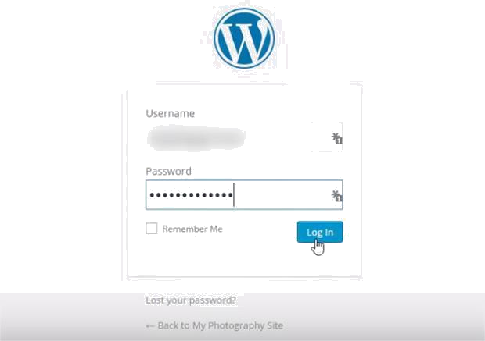

* 1. You can install a WordPress theme in your admin area by going to **Appearance » Themes** and clicking on the **Add New** button at the top.

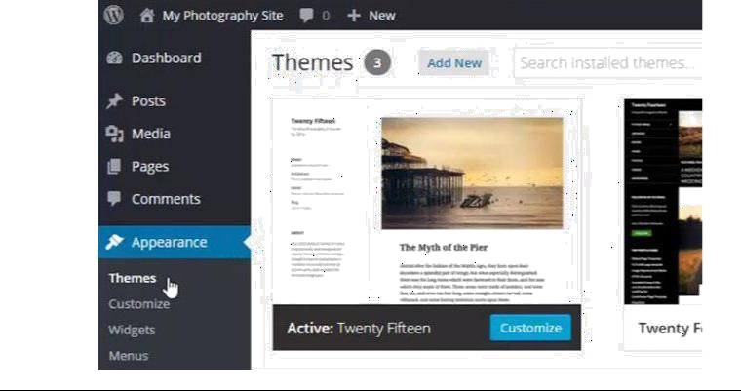

* 1. Write ‘photography’ in the search bar and hit the enter button.

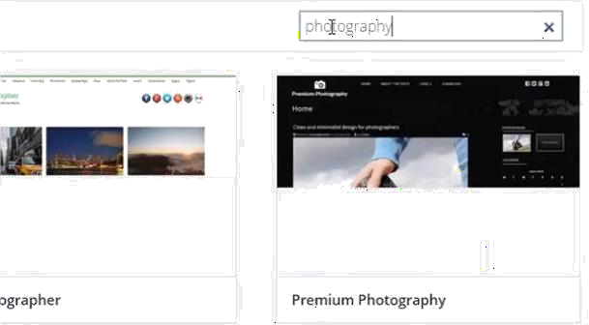

* 1. We are selecting the *Patio* photography theme. It is a beautiful WordPress theme for photographers.

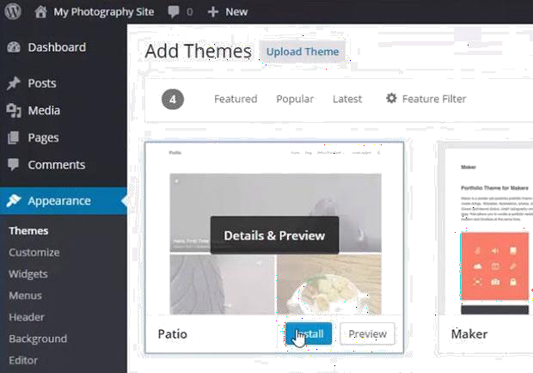

* 1. You need to click on the Install button from *Patio* theme and then click on the Activate link from the next screen.

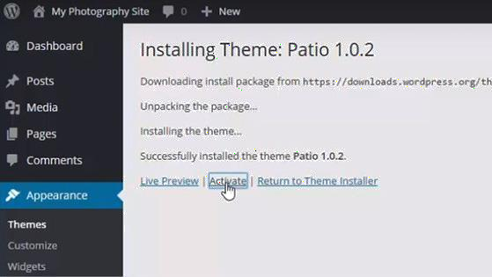

* 1. Add Pages and Posts in Your Website After activating the theme, you can go ahead to Pages » Add New to add your website pages one by one.

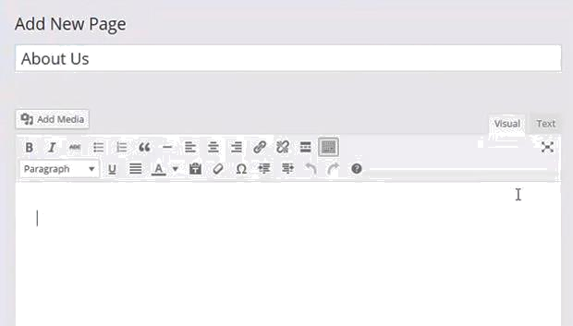

* 1. Once you have created a few pages, simply go to Appearance » Menus to create the menu for your website and click on the *‘create a new menu’* link.

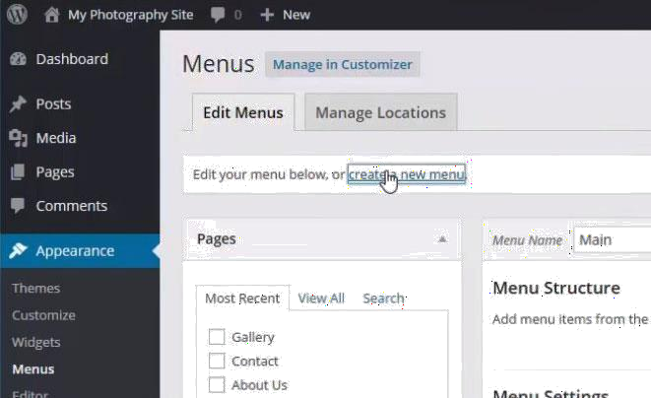

* 1. You will need to give a name to your menu and click on the Create Menu button.

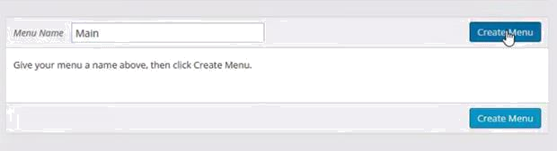

* 1. Once the pages are added, you can go to Posts » Add New to add a new blog post in WordPress.

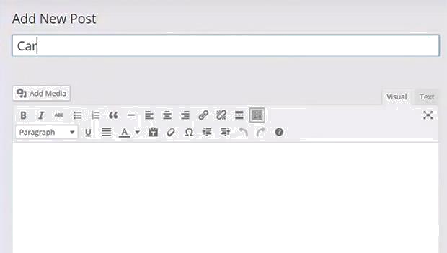

* 1. You can edit these posts to add content and images for display on your photography website.
  2. With all these and many more plug ins you can develop your website easily using wordpress.

## Website Deployment

When the process of website development is complete, its needs to be deployed on a web server. When development of website is completed, it is tested for its final working and ready to be hosted on a live web server. The hosting of a website on a web server involves the following steps:

a. Domain registration

b. Domain hosting

c. parking websites

1. uploading data using FTP
2. email configuration

**Conclusion:** The various features of CMS have been studied and Wordpress have been used to develope a mini project

### Lab. Based FAQ

1. What is CMS? What are its advantages?
2. What are various CMS tools?
3. How Wordpress is used for creation of interactive website?
4. What are the steps to deploy a website on web server?
5. Explain concept of Parking a website.

# Assignment No:7

## Aim: Evaluation of Interface

**Problem statement:**

Students are expected to evaluate minimum of two products / software interface against known HCI evaluation.

**Evaluate UI designed for CMS assignment using Nielsen’s Heuristic evaluation technique**

**Nielsen's heuristics Rules:**

1. Visibility of system status: ...
2. Match between system and the real world: ...
3. User control and freedom: ...
4. Consistency and standards: ...
5. Error prevention: ...
6. Recognition rather than recall: ...
7. Flexibility and efficiency of use: ...
8. Aesthetic and minimalist design:
9. Help users recognize, diagnose, and recover from errors:
10. Help and documentation:

**Evaluate any UI / product using Ben Shneiderman’s eight golden rules for interface design. Shneiderman's Eight Golden Rules of Interface Design**

* 1. Strive for Consistency. ...
  2. Enable Frequent Users to Use Shortcuts. ...
  3. Offer Informative Feedback. ...
  4. Design Dialog to Yield Closure. ...
  5. Offer Simple Error Handling. ...
  6. Permit Easy Reversal of Actions. ...
  7. Support Internal Locus of Control. ...
  8. Reduce Short-Term Memory Load.

## Theory:

**Evaluation in HCI**

It is difficult to imagine that an interactive product could be designed and built without any user-focussed evaluations taking place. It is not possible to pick up a HCI textbook that does not include at least a chapter on the evaluation of user interfaces. The way in which these usability evaluation methods are presented and classified varies between authors. In 1994, Nielsen claimed that there were four basic ways of evaluating user interfaces; these being

* Automatically
* Empirically
* Formally
* Informally

|  |  |
| --- | --- |
| He went on to suggest that automatic and formal evaluations were both problematic, and suggested that only empirical and informal methods were really useful (Nielsen 1994). This has become the accepted viewpoint in the usability community. Usability Evaluation Methods can generally be described as either empirical or informal using Nielsen’s words. The following table shows a list of Usability Evaluation methods, categorized in this way. **Empirical Methods** | **Informal Evaluations** |
| User Walkthrough | Heuristic Evaluation |
| Focus groups | Expert reviews |
| Structured observations | Cognitive walkthroughs |
| Cooperative evaluations | Predictive modelling – GOMS |
| Activity logging | Guidelines review |
| Data logging | Consistency inspection |
| Observations | Critical event analysis |
| Questionnaires | Dialogue Error Analysis |
| Interviews | Usability testing |
| Controlled user tests | |
| Physiological data analysis | |

Different authors divide evaluation in different ways. In User Interface Design, they are broken into formative and summative methods (Le Peuple and Scane 2003). Formative evaluations take place early in the design process and the results of these evaluations inform the later design. (Shneiderman 1998)divides evaluation by considering who the evaluator is. This results in expert reviews and novice reviews. (Faulkner 1998) compares analytical and statistical methods. In John Carrolls design,, the issues of evaluation of learner centred interfaces is touched on.

## How Evaluation methods are evaluated

Given the large number of methods available, and the many different ways of classifying them, it can be difficult to know which methods should be used. There is an abundance of literature on the evaluation of evaluation methods.

Work by (Nielsen and Phillips 1993) focussed on GOMS, Heuristics and User testing. These were used with three different views of the design, cold, warm and hot. The cold testing took place with just a written specification, the warm test was carried out with a limited time on a prototype (about an hour), and for the hot test, testers could play on the prototype for as long as they wanted. The user testing activity was only used with the end product. It was a within subjects design and subjects were allowed to practice until they plateau-ed. They had a sequence of tasks to

do during which error messages and feedback were given and this activity was followed by a subjective satisfaction questionnaire.

The findings were that the estimates between experts doing GOMS and Heuristic evaluations were very varied. This suggested that it is best to not rely on a single inspection. Other authors have made similar observations. (REFS) The cost of a heuristic evaluation with a hot view of the design was costlier than the user test and it was remarked that unless the product is unstable, or users are unavailable, the user test was preferred at this stage. (Savage 1996) compared expert reviews, user reviews and user testing. In this study, expert reviews were defined to be inspection methods carried out by human factors specialists. These included heuristic evaluations, cognitive and pluralistic walkthroughs, and consistency and standards inspections. The usability tests were conducted in a role-play interaction using a talk aloud session. User reviews involved potential end users in viewing slide shows of the product and completing questionnaires and engaging in group discussion. Results from this study were that expert reviews tended to inform user interface issues that needed more research with end users; the other two methods flagged up design issues. Heuristic evaluations and user tests have been shown in some studies to identify discrete sets of usability problems (Law and Hvannberg 2002).

In industry, user testing, where users are brought into a lab and asked to think aloud while performing tasks, and are later questioned about their experience of the software, is the most widely used technique (Nielsen and Mack 1994). Cognitive walkthroughs (Wharton, Rieman et al. 1994), Heuristic Evaluations (Nielsen 1994) and GOMS (Card, Moran et al. 1983) are all more economical as they do not require running a prototype or actual users. Empirical methods rely on the availability of real users to test the interface, whereas informal evaluations rely on the skill and experience of the evaluator. The recommended number of evaluators for a heuristic evaluation is 3 – 5 and Nielsen has claimed that five subjects are enough for a usability test as well. In some instances where users are scarce, users may need to be saved for a user test, thus forcing the need for expert reviews. (Nielsen 1994)

However, (John 1996) points out that there are many questions that remain about all these techniques including

* Is the technique real world enough?
* Does it find faults and fixes, or just faults?
* When in the development process should it be used?
* How does it fare in a cost benefit analysis?
* How can techniques be best used together?
* What are the costs of learning a new technique?

## Designing an Evaluation Strategy

Determinants (Shneiderman 1998)

* Stage of design
* Novelty of project
* Number of expected users
* Criticality of the interface
* Costs of product and finances available for testing
* Time available
* Experience of the design and evaluation team

It is possible to simplify these into four stages; these being.

* Purpose of the product – users would be defined here
* Availability of resources
* Stage of the project
* Purpose of the evaluation

These dimensions are described in the following section

## Purpose of Evaluation

The Evaluation will have its’ own purpose, it may be to

* Predict problems
* Discover problems
* Evaluate against another product

This may change over a product design lifecycle. It is possible that the evaluator may want one evaluation to cover all three aspects.

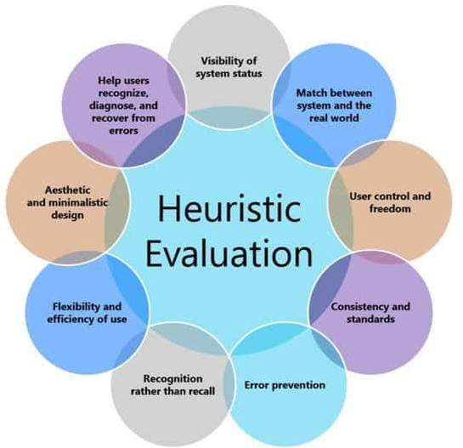

## Strive for consistency:

**Example: Consistent colors and fonts**

**Explanation:** Consistent colours and fonts can be seen on google pay application. The icons are arranged in a proper fashion to make the user experience convenient.

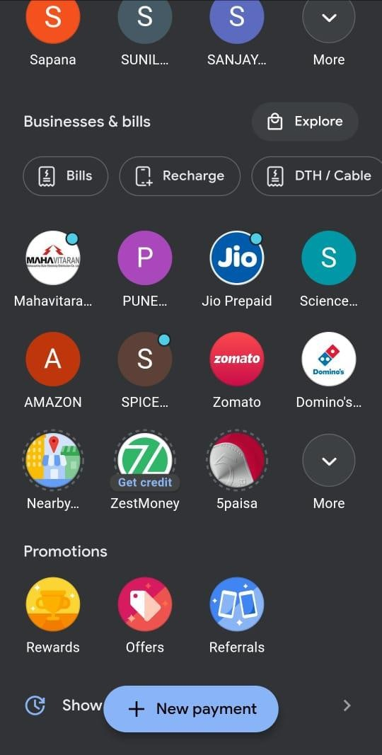

## Enable frequent users to use shortcuts:

**Example: QR Scanner**

**Explanation:** QR scanner can be directly accessed from home page instead of going to new payment-

>upi/QR->QR code scanner

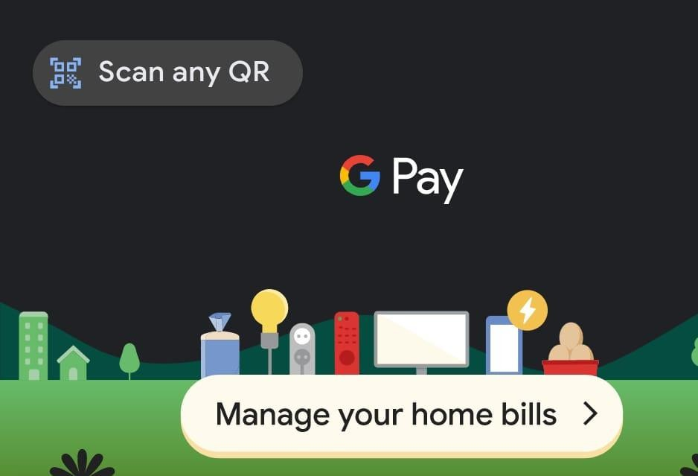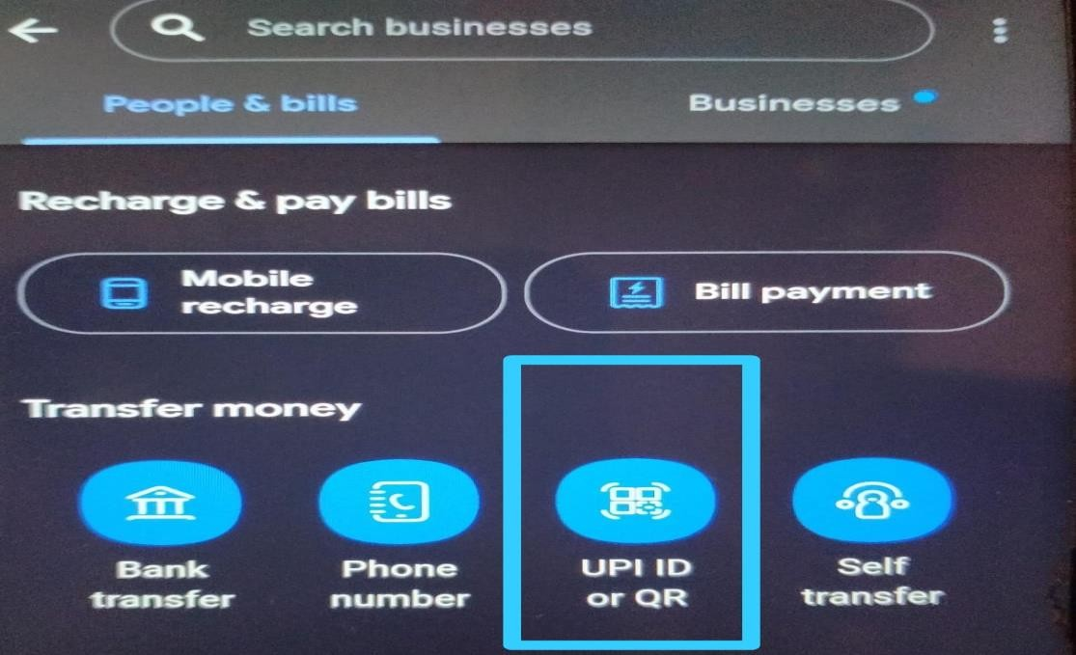

## Offer Informative Feedback:

**Example: Status**

**Explanation:** When a payment is done or received the status of payment is displayed below the amount.

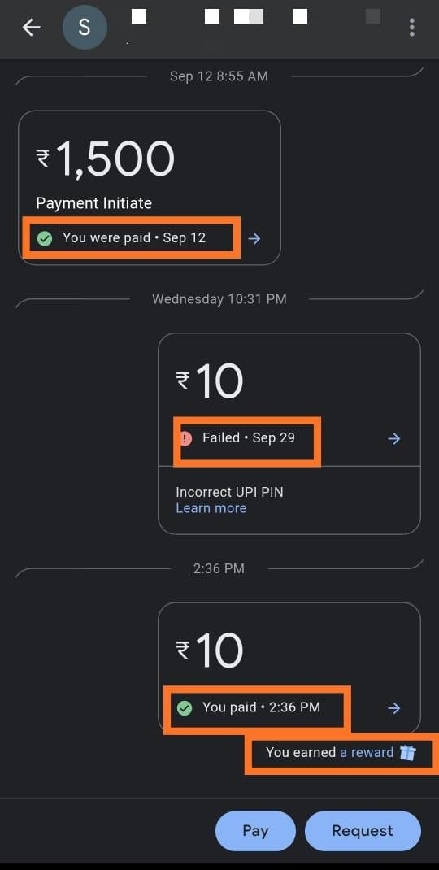

## Design Dialog to Yield Closure:

**Example: Check after successful transaction**

**Explanation:** After the amount has been successfully transacted from the account a blue tick pops up with a notification sound indicating that the operation was successful.



## Offer error prevention and simple error handling: Example: If the UPI ID holder does not accept payment request

**Explanation:** While transacting money if the given UPI ID is not accepting requests then bank server unavailable error shows up.

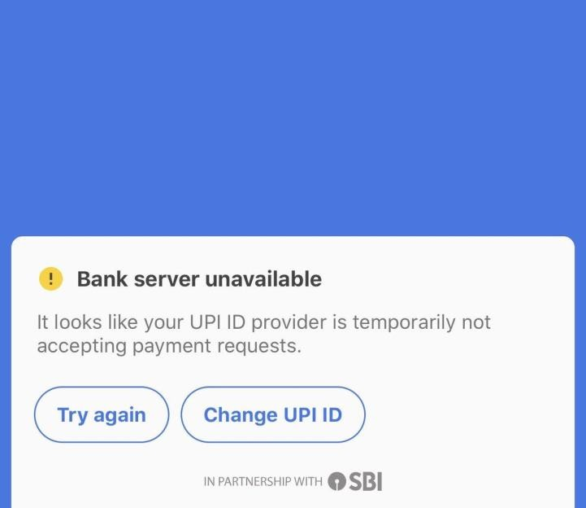

## Permit easy reversal of actions:

**Example: Blocking and Unblocking**

**Explanation:** User can block any contact and can unblock it again.

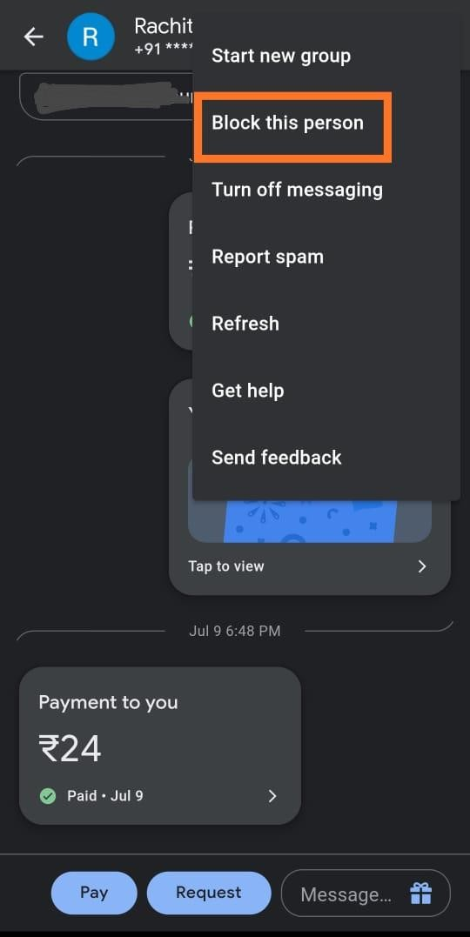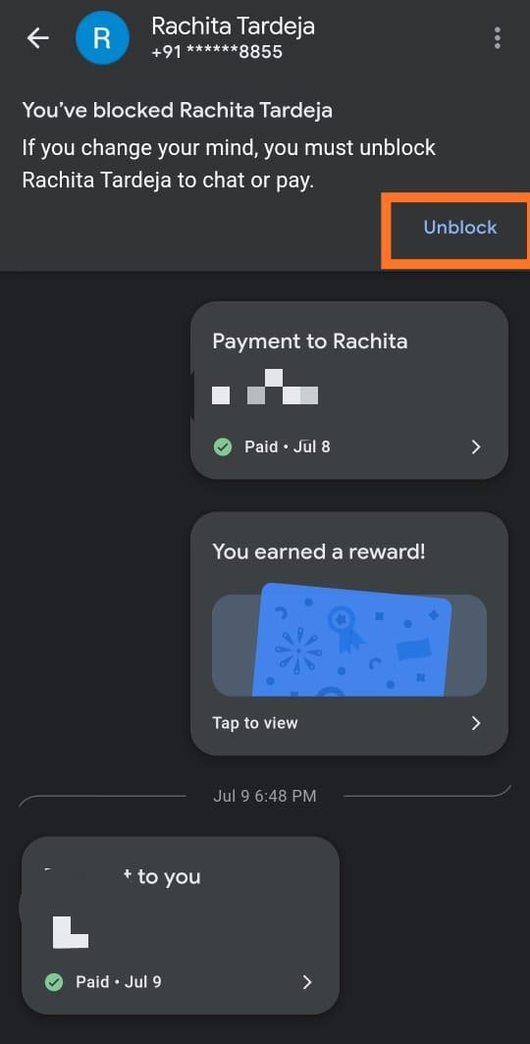

## Support internal locus of control:

**Example: Messaging**

**Explanation:** If a user turns off messaging he will still receive the payment regarding updates.

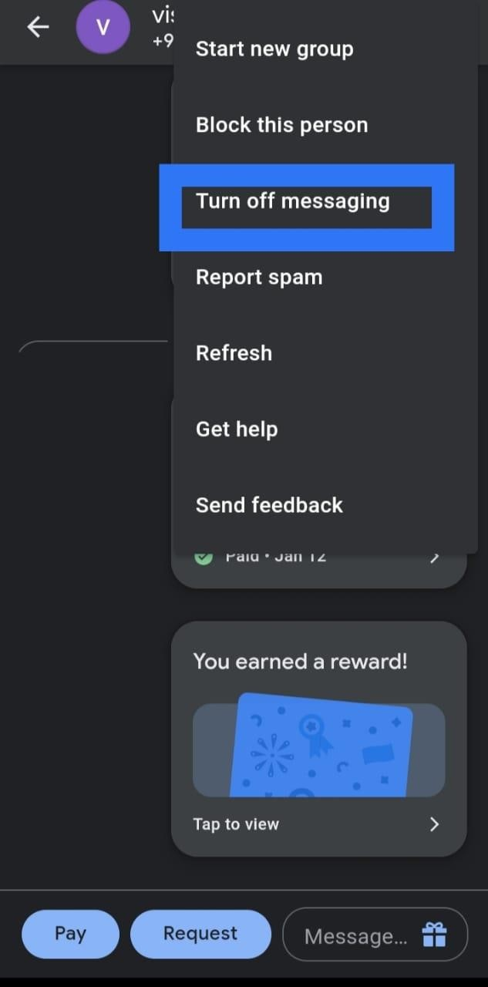

## Reduce Short-Term Memory Load:

**Example: Transaction History**

**Explanation:** Transaction history is properly maintained to keep a track of payments made making it convenient for user.

